**Project Design Phase-II**

**Data Flow Diagram & User Stories**

|  |  |
| --- | --- |
| Date | 03 October 2022 |
| Team ID | PNT2022TMID44913 |
| Project Name | Project - Natural Disaster Intensity Analysis and Classification Using Artificial Intelligence |
| Maximum Marks | 4 Marks |

**Data Flow Diagrams:**

A Data Flow Diagram (DFD) is a traditional visual representation of the information flows within a system. A neat and clear DFD can depict the right amount of the system requirement graphically. It shows how data enters and leaves the system, what changes the information, and where data is stored.

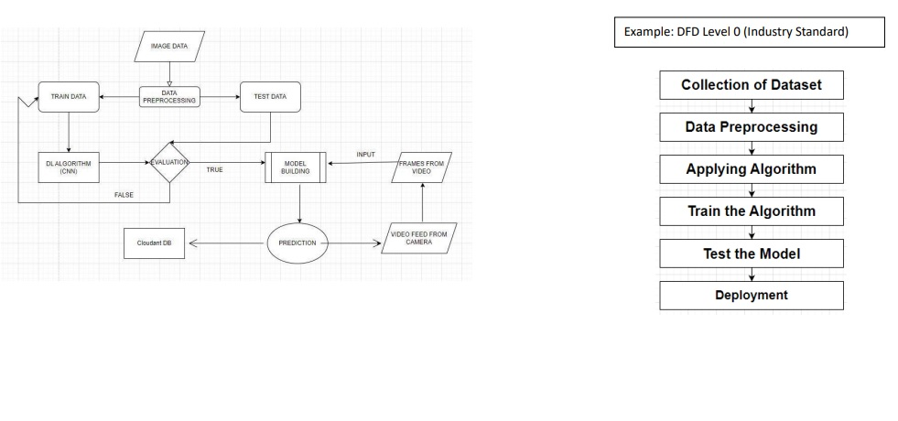

**User Stories**

Use the below template to list all the user stories for the product.

| **User Type** | **Functional Requirement (Epic)** | **User Story Number** | **User Story / Task** | **Acceptance criteria** | **Priority** | **Release** |
| --- | --- | --- | --- | --- | --- | --- |
| Customer (Mobile user) | Registration | USN-1 | As a user, I can register for the application by entering my email, password, and confirming my password. | I can access my account / dashboard | High | Sprint-1 |
|  |  | USN-2 | As a user, I will receive confirmation email once I have registered for the application | I can receive confirmation email & click confirm | High | Sprint-1 |
|  |  | USN-3 | As a user, I can register for the application through Facebook | I can register & access the dashboard with Facebook Login | Low | Sprint-2 |
|  |  | USN-4 | As a user, I can register for the application through Gmail | I can login with my password | Medium | Sprint-1 |
|  | Login | USN-5 | As a user, I can log into the application by entering email & password | I can see the dashboard now | High | Sprint-1 |
|  | Dashboard | USN-6 | As a user, I can update Disaster incidents. | I can update now | Medium | Sprint-1 |
| Customer (Web user) |  | USN-7 | As a user, I can view Map Data. | I can see Map Data | Medium | Sprint-1 |
| Customer Care Executive | Authentication | USN-8 | As a Community Leader, I can log into the application using my password | I can access my account. | High | Sprint-1 |
| Administrator | Register | USN-9 | The user can register for the application through official Gmail account | They can register and access the dashboard | Medium | Sprint-2 |